Source Code

package travelpackage;

import java.util.Scanner;

/\*\*

\*

\* @author User

\*/

public class TRAVELPACKAGE {

/\*\*

\* @param args the command line arguments

\*/

public static void main(String[] args) {

// TODO code application logic here

Scanner scan = new Scanner(System.in);

Travel[] travel = new Travel[5];

for(int i =0; i<travel.length; i++){

try{

System.out.println("Package Title: ");

String Title = scan.nextLine();

System.out.println("Description : ");

String Description = scan.nextLine();

System.out.println("Price for single person: ");

double Price = scan.nextDouble();

System.out.println("Travel duration : ");

double Duration = scan.nextDouble();

scan.nextLine();

travel[i] = new Travel(Title,Description,Price,Duration);

}catch(Exception e){

System.out.println("Invalid"+" \nPlease enter a data again");

main(args);

}

}

System.out.println("#################");

for(int i =0; i<travel.length; i++){

System.out.println("Packages title :"+ travel[i].getTitle());

System.out.println("Description :"+ travel[i].getDescription());

System.out.println("Price for single person : RM "+ travel[i].getPrice());

System.out.println("Travel duration :"+ travel[i].getDuration());

System.out.println("#################");

}

}

}

Class

package travelpackage;

/\*\*

\*

\* @author User

\*/

class Travel {

private String Title; String Description;

private double Price; double Duration;

private String Tittle;

Travel(String Title,String Description,double Price,double Duration){

this.Title = Title;

this.Description = Description;

this.Price = Price;

this.Duration = Duration;

}

String getTitle(){

return Title;

}

String getDescription(){

return Description;

}

double getPrice(){

return Price;

}

double getDuration(){

return Duration;

}

void setPrice(double Price){

this.Title = Title;

}

void setDuration(double Duration){

this.Title = Title;

}

void setDescription(String Description){

this.Tittle = Title;

}

}

Screenshot

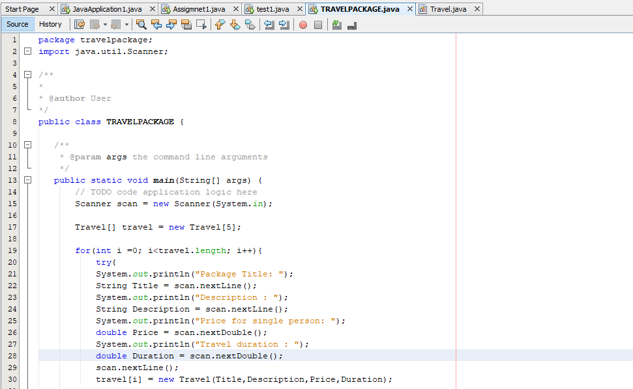

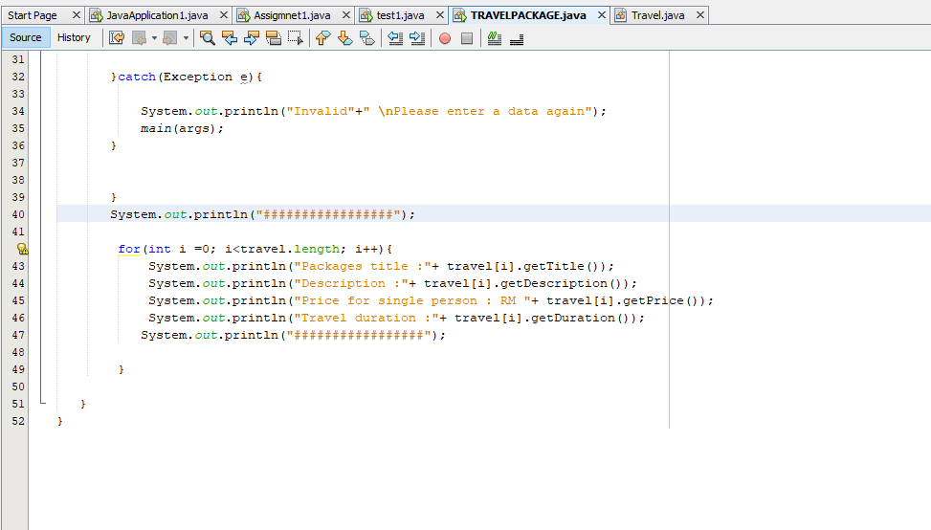

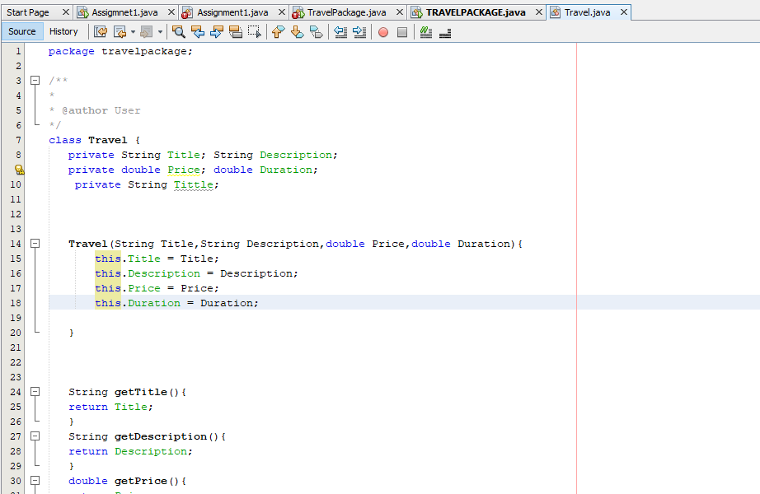

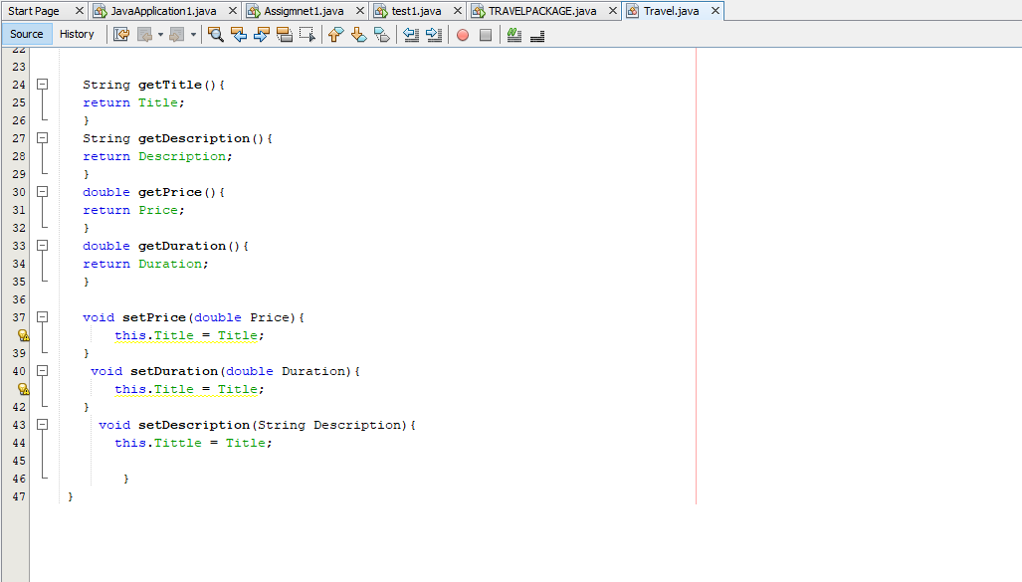

Input

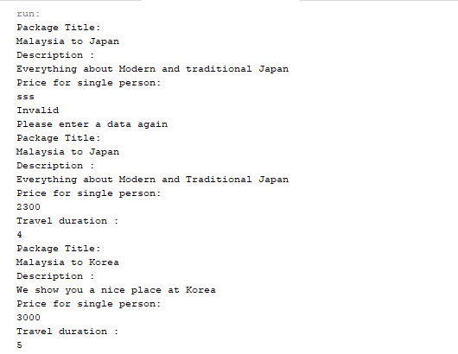

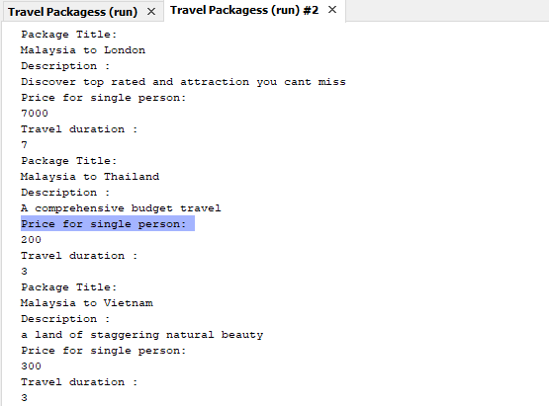

Output

